HazLoc LED LUMINAIRE
Installation and Maintenance Manual
HazLoc L1102J

Top Hi-Tech Co., Ltd.
9F, No.1, Zhongshan Road, Tucheng Dist. New Taipei City, 23680,236 Taiwan
Website: www.tht-ex.com
TEL: +886 2 2267-1234
FAX: +886 2 2269-1166
e-mail: sales@tht-ex.com
Pub. Code:
Subject to alterations

- General Information

HazLoc L1102J LED Luminaires are suitable for use in the following hazardous (classified) areas as defined by the National Electrical Code (NEC) and Canadian Electrical Code (CEC):
- Class I, Division 2, Groups A, B, C, D
- Wet Locations (UL 1598)

Refer to the luminaire nameplate for specific classification information, maximum ambient temperature suitability and corresponding operating temperature (T-Code).

HazLoc L1102J LED Luminaire is designed for using in indoors and outdoors environment.

Rated Voltage(COB): 120/277/480 Vac, 50 & 60 Hz
Rated Voltage(SMD): 120/277Vac, 50 & 60 Hz
Ambient Temperate Range: -40°C ~ +40°C
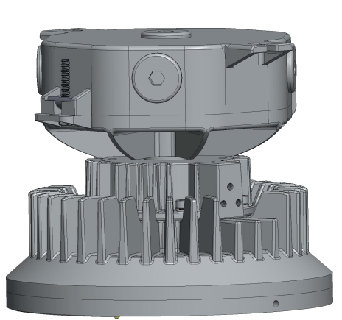

____________________________________________________________________________________________

WARNING
- To avoid the risk of fire, explosion or electric shock, this product should be installed, inspected and maintained by a qualified electrician only, in accordance with all applicable codes and regulations.

- To avoid electric shock:
- Be certain electrical power is OFF before and during installation and maintenance.
- Luminaire must be supplied by a wiring system with an equipment grounding conductor.

- To avoid explosion:
- Make sure that the supply voltage is the same as the luminaire voltage.
- Do not install where the marked operating temperatures exceed the ignition temperature of the hazardous atmosphere.
- Do not operate in ambient temperatures above those indicated on the luminaire nameplate.
- All gasket seals must be clean and undamaged.
- Use proper supply wiring as specified on the luminaire nameplate.
- Before dismounting, electrical power to the luminaire must be turned off. Keep tightly closed when in operation.

- To avoid burning hands, ensure the luminaire is cool when performing maintenance.
____________________________________________________________________________________________

- Dimensions (All Dimensions in mm) – Subject to Alterations
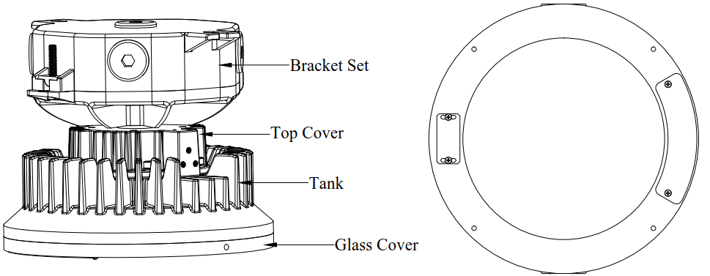

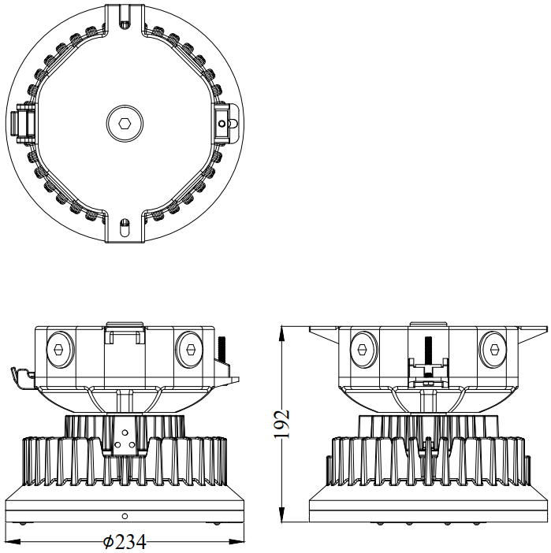

- Technical Data
Item | Description
Rated Voltage | 120/277/480 Vac, 50 & 60 Hz (Note information on type label)
Power Factor | cos φ ≧ 0.9
Ambient Temperate Range | -40°C ~ +40°C
Material  Enclosure  Glass | Aluminum alloy  Temperature-resistant pressed glass
LED Service Life | 60,000 hrs
Mounting Type | Ceiling Mounting
Mounting Type | 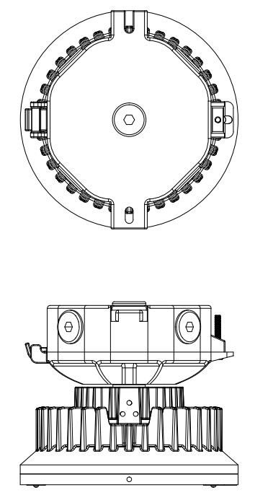

- Assembly and Installation

  - Mounting Bracket Installation

    - Ceiling Mounting Bracket

- Fix and Introduce the wires of luminary with the terminal post of Ceiling Bracket (White-wire connects to Neutral; Black-wire connects to Live; Green-wire connects to Ground.)
- The mounting bracket is for the use of Ceiling mounting type.
- Position the bracket holders and fix it by means of the provided M8 screws, 61.0 kgf-cm.
- Capturing the luminaires hinge pin inside the adapter hinge hook, clamp the adapter down, Thread the captive closing screw into theadapter, and tighten it to 30 in.-lbs (3.4 N-m).

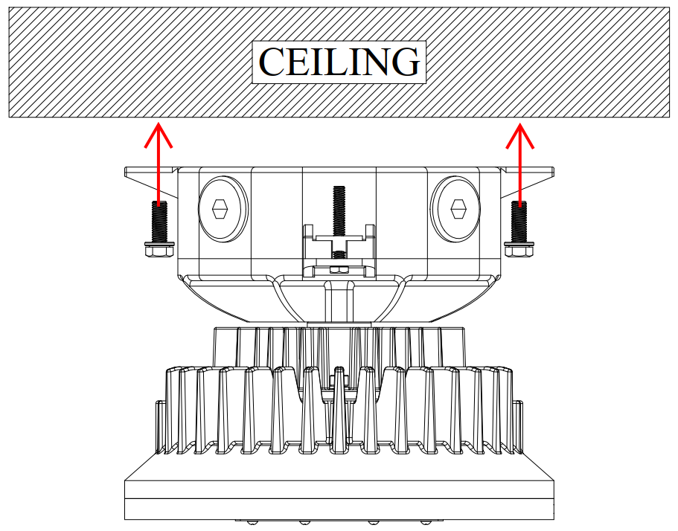

  - Putting into Service
Before putting into operating, it’s necessary to ensure that:
- the lighting is correctly installed.
- the connection has been correctly made.
- the cable has been inserted correctly.

- Maintenance
- To avoid personal injury, disconnect power to the light and allow the unit to cool down before performing maintenance.
- Perform visual, electrical, and mechanical inspections on a regular basis. The environment and frequency of use should determine this. However, it is recommended that checks be made at least once a year. Frequency of use and environment should determine this. It is recommended to follow an Electrical Preventive Maintenance Program as described in the National Fire Protection Association Bulletin NFPA No. 70B: Recommended Practice for Electrical Equipment Maintenance.
- The lens should be cleaned periodically to ensure continued lighting performance. Clean the lens with a clean, damp, non-abrasive, lint-free cloth. If this is not sufficient, use a mild soap or a liquid cleaner. Do not use an abrasive, strong alkaline or acid cleaner as damage may occur.
- Inspect the cooling fins on the luminaire to ensure that they are free of any contamination (i.e. excessive dust build-up). Clean with a non-abrasive cloth if needed.
- Electrically check to make sure that all connections are clean and tight.
- Mechanically check that all parts are properly assembled.
- Transport, Storage and Disposal
- Transport and storage is only allowed in the original packaging, on the way pointed out on the carton box.
- Transport – Shock-free in its original carton, do not drop, and handle carefully.
- Store – Store in a dry place in its original packaging.
- Disposal – Ensure environmentally friendly disposal of all components according to the legal regulations.

